

HIGHNOON
LABORATORIES LTD.

FINANCIAL MANAGEMENT

PROJECT:

HIGHNOON LABORATORIES LTD.
(ANNUAL REPORT ANALYSIS)

PRSENTED TO:

PROF. SHAHID MEHMOOD

PRESENTED BY:

Institute of Business Administration
UNIVERSITY OF THE PUNJAB

CONTENTS

TOPICS PAGE NO

Dedication

In the name of ALLAH, the most Beneficial, the most Merciful. We are very thankful to Almighty Allah who has given us power to complete this proposal, although we were not able to write even a single word without his help.This report is dedicated to Prof. Shahid who had worked hard and explained the Financial Management in such a way that everyone in the class became familiar to this technical subject. We admire his dedication, devotion and commitment to noble / dignified profession.
PHARMACEUTICAL INDUSTRY IN PAKISTAN
Chemical and pharmaceutical sector had the largest direct foreign investment prior to the massive foreign investment in the power sector. However, while looking at the number of companies it is still the largest sector. It also has the largest number of listed companies with investment from multi and transnational companies. The sector could be divided into two main subsectors — chemicals and pharmaceuticals. The presence of companies like ICI, Abbott, Sandoz, Ciba, Pfizer and Reckitt & Colman have not only been a major contributors in the economic development of the country but also a source of inspiration for other multinational companies in search of a place to invest and offering good return on investment.
Imperial Chemical Industries (ICI) entered into the region, now comprising Pakistan, in early forties by establishing a soda ash plant at Khewara, so we can say that the history of pharmaceutical industry of Pakistan is as as old as that of Pakistan, ICI being the pioneer.
Pharmaceutical industry was the second industry, after textile, which had the biggest investment to produce goods of international quality on state-of-the-art machines. It is providing jobs to about 100,000 people directly and to thousands of others indirectly.

The pharmaceutical industry plays a pivotal role in the economic development of the country by ensuring better health to the people through supplying cheaper and quality drugs. The pharmaceutical industry in Pakistan comprises national and multinational companies.
Presently there are about 316 pharmaceutical manufacturing companies including 30 multinationals, which are meeting around 80% of the country’s requirement.

Table Below Shows: Province-wise distribution of pharmaceutical industry

Provinces | National | MNCs
Punjab | 165 | 5
Sindh | 76 | 23
NWFP | 37 | -
Baluchistan | 5 | 2
Azad Jammu & Kashmir | 3 | -
Total | 286 | 30
Source: Ministry of Health

Total capital investment in this sector is Rs.21.12 billion divided almost evenly between national and multinational companies.

INTRODUCTION TO THE COMPANY

Highnoon was incorporated in 1984 in the historical and culturally rich city of Lahore, called the heart of Pakistan. From the very beginning Highnoon embarked on a relentless pursuit of excellence led by its visionary chairman. Leading from the front, he developed a culture of commitment, fierce competitiveness and distinction in every area of the company’s operations.

Strategic alliances with some of the best known names in the global pharmaceutical industry were forged. Highnoon has since then, marched ahead introducing state of the art products and setting new trends in the industry. Highnoon’s therapeutic focus in cardiology, gastroenterology and psychiatry has lead to development of franchises, which are now the most admired in the healthcare industry. These are the company’s highly prized assets, as a symbol of its enterprising approach. Innovation has been a highly sought after attribute at Highnoon all along. From the very first product to the very recent introductions, speak volumes of ingenuity behind product selection and portfolio development.

Vision:
We at Highnoon Laboratories Limited understand the duties of being responsible corporate citizen and stand true to our conviction and promise to work for the betterment and prosperity of our people.

Our Mission:
We strive to maintain excellence in our business with the objective to benefit the medical community, consumers, stakeholders and employees; and to improve quality of life by providing quality products.

Objectives:
- Excel in meeting customer needs.
- Maintain leadership in national pharmaceutical industry.
- Gain confidence of Doctors, Pharmacists and Consumers who use our products.
- Seek employee involvement, continuous improvement and enhanced performance goals.
- Enhance export business.

Auditors:
To comply with the requirement of the Code of Corporate Governance as applicable on Listed Companies regarding change of Auditors after every five years, the Audit Committee has recommended the appointment of Taseer Hadi Khalid & Co. , Chartered Accountants as Auditors for 2004. The BOD has endorsed the recommendation of the Audit Committee.
The existing auditors Ford Rhodes Sidat Hyder & Co., will retire at the conclusion of the 21st Annual General Meeting. The directors wish to place on record and acknowledge the highest standards of professional independence, objective and effectiveness depicted since the day of their initial appointment.

CHAIRMAN’S REVIEW:
On behalf of the Board of Directors, it gives me great pleasure to welcome you to the 21st Annual General Meeting of Highnoon Laboratories Limited.

Business Environment:

the events like corporate scandals and bankruptcies in United States resulting in bursting of the equity market, rising oil prices due to Iraq war and outbreak of SARS virus has negative impact on the business environment in Asia and adversely affected growth in the region.
In Pakistan the consistent Government policies have paved the way for a sharp pickup of growth accompanied by low inflation and interest rates, continued build up in Foreign Exchange reserves, decline in domestic and external debt, buoyant stock markets, improved credit ratings and rising inflow of foreign direct investments, which have been the key achievements of the outgoing year.
Consequently, the operating environment for the Pharmaceutical Industry also showed relative stability during the first half of 2003.

Marketing:

With sales growth of 15.78%, the year 2003 was one of the most prosperous periods for your company. This growth is in indicator of the strength of our existing portfolio as well as the aggressiveness with which your Company is concentrating on new business opportunities. In terms of market standing, we maintained our ranking as the 16th largest pharmaceutical company in Pakistan.

Production:

Your Company keeps on investing in new machinery and equipment with consistent up-gradation of the Production facilities. The company has purchased and commissioned a customized and state-of-the-art humidity and temperature controlling system for its antibiotic facility to handle the manufacturing of extremely sensitive antibiotic dosage forms.

Research & Development:

Research & Development augments the productivity of a company while accumulating a new elevation to its outlook. Hignoon is a pioneer in this sphere of influence and till date enjoys an exclusive honor of developing a novel research product patented in Pakistan. though an expensive venture, Highnoon Laboratories Limited has always understood the importance of the function for remaining competitive and dynamic. The company in the year 2003 developed seven new formulations under following brand names, which have already been launched during the year in progress.

These include:

Antibiotic Medicine (Broad Spectrum Semi-synthetoc Pencillin)

Termibex (Co-amoxiclav)
- 375 mg & 625 mg Tablets.
- 156.25mg & 625 mg. 5ml Dry Suspensions

Lipid Regualting Medicine

Lipirex (Atrovastatin)
- 10mg, 20mg & 40mg Tablets

Bseides developing these products we also developed four new Products for toll manufacturing. Almost more than a dozen new formulations have neen developed in the year 2003 and will be launched in near future after obtaining regulatory approvals.

Quality Assurance:

Quality Assurance is the essence of pharmaceutical manufacturing entity. It has a significant function in establishing the reliability and efficacy of a drug. Highnoon comprehends the worth of this essential division and regulatory inducts new and sophisticated equipment to met the continuously changing regulatory, GMP and pharmacopoeial requirements. This year your Copmpany has produced a microprocessor controlled High Performance Liquid Chromatograph (HPLC) and an Air Particle Counter for Quality Assurance Lab. A GMP Compliant Stability chamber is also in the pipeline to further strengthen stability studies and validation system of the QA Lab.

Exports:

All our efforts are continuing for reaching out the world and providing quality medicines at
affordable prices. With export registrations of about 175 products in various countries and of many products in the pipeline, numerous potential regions are being added every year to achieve the overall organization objective of increasing exports.

Ratio Analysis

RATIO ANALYSIS

Sr.No |  |  | 2002 | 2003 | 2004 | 2005
 | LIQUIDITY RATIOS
1 | QUICK RATIO | TIMES | 0.28 | 0.35 | 0.37 | 0.46
2 | CURRENT RATIO | TIMES | 1.12 | 1.18 | 1.17 | 1.18
 | ACTIVITY RATIOS
3 | A/R TURN OVER | TIMES | 19.57 | 21.33 | 22.30 | 18.88
4 | AVG COLLECTION PERIOD | DAYS | 18.65 | 17 | 16 | 19
5 | INVENTORY TURN OVER | TIMES | 2.34 | 2.43 | 2.64 | 2.89
6 | AVG AGE OF INVENTORY | DAYS | 156 | 150 | 138 | 126
7 | TOTAL ASSET TURN OVER | TIMES | 1.07 | 1.23 | 1.02 | 1.16
 | LEVERAGE RATIO
8 | TOTAL CAPITALIZATION | TIMES | 0.90 | 0.88 | 0.92 | 0.94
9 | DEBT TO EQUITY | TIMES | 1.22 | 1.27 | 1.3 | 1.32
10 | INTEREST COVERAGE RATIO | TIMES | 2.02 | 2.99 | 4.23 | 3.22
11 | DEBT TO ASSET RATIO | TIMES | 0.812 | 0.854 | 0.85 | 0.837
 | PROFITABILITY RATIOS
12 | GROSS PROFIT MARGIN | % | 38.47 | 38.23 | 36.60 | 36.12
13 | NET PROFIT MARGIN | % | 4.49 | 4.07 | 3.74 | 4.05
14 | RETURN ON CAPITAL EMPLOYED | % | 14.13 | 14.17 | 11.77 | 14.88
15 | RETURN ON EQUITY | % | 17.45 | 16.70 | 14.97 | 16.41
16 | RETURN ON INVESTMENT | % | 6.29 | 8.86 | 7.08 | 6.88
 | MARKET RATIOS
17 | EARNING PER SHARE | TIMES | 3.44 | 3.55 | 3.88 | 4.45
18 | PRICE EARNING RATIO | TIMES | 4.85 | 8.48 | 10.41 | 9.13
19 | DIVIDEND PER SHARE | TIMES | 1.50 | 2.50 | 1.50 | 1.50
20 | CASH COVERAGE RATIO | TIMES | 2.89 | 3.25 | 3.70 | 2.56
21 | BOOK VALUE PER SHARE | Rs. | 21.67 | 21.28 | 25.89 | 27.12
22 | MKT TO BOOK VALUE PER SHARE | TIMES | 0.77 | 1.41 | 1.56 | 1.50

LIQUIDITY RATIOS
These ratios determine the company ability to meet its maturing short-term obligations. Through these ratios we are expected the future cash flows. The company appears to have a good liquidity position and can meet its short term obligation.
1. QUICK RATIO:

Quick ratio = Quick Assets
Current liabilities

It is used to test the most current assets against current liabilities. The company quick ratio shows as increase trend with a decrease rate, as it was 0.28 in 2002, which is increase to 0.46 in 2005.

2. CURRENT RATIO:

Current ratio = Current Assets
Current Liabilities

A high current ratio is required when the firm is going to borrowing short-term loans. So short-term creditors are always interested in current ratio. As the company current ratio is good it indicates that company can pay its short tern obligations as they come due. The company current ratio shows a unfavorable trend as it was 1.12 in year 2002 and in year 2005 it was 1.18. It shows that company has not maintained its current ratio. This shows that company does not maintain excessive cash on hand. There was a slightly decrease in current ratio in year 2004 as compare to previous year because of relative more increase in current liabilities as compare to current asset. The increase in current liabilities was mainly due to the increase in creditors and other liabilities.

GRAPHICAL SHOW OF QUICK AND CURRENT RATIO

0
0
0.2
0.2
0.4
0.4
0.6
0.6
0.8
0.8
1
1
1.2
1.2
1.4
1.4
2002
2002
2003
2003
2004
2004
2005
2005
CR
CR
QUICK RATIO
QUICK RATIO

ACTIVITY RATIOS:
Activity ratios are used to determine how quickly various accounts are converted into sales or cash. The company’s activity ratios are exceptionally high and have increased during the period.

3. Accounts receivable turnover ratio

A/R turnover ratio = Net Sales
Avg. A/R

It measures the effectiveness of the firm’s credit policies and indicates the level of investment in receivables needed to maintain the sales level. The A/R turnover ratio has decreased over the period. In year in 2002 it was 19.97 and in year 2005 it was 18.88. This shows firm not collecting its receivables early and it has not tighten its policy. This might be attributed to the increase in credit sales. This is not a good sign because company cannot collect its cash early while it has badly affected the sales.

4. Average collection period

Avg. collection period = 365
A/R turnover ratio

It measures the effectiveness of the firm’s credit policies and indicates the level of investment in receivables needed to maintain the sales level. The Average collection period ratio has increased over the period. In year 2002 it was 18 days and in year 2005 it has increased to 19 days. The high the Average collection period ratio shows that firm have no strict policy.

5. Inventory turnover ratio

Inventory Turnover = CGS
Average inventory
.

The inventory turnover shows increasing trend. As it was 2.34 times in 2002 which increase in 2005 to 2.89. .The inventory is turned into Finished good. In case of the company, which we have selected there is gradual increase in inventory turnover it means the inventory is turning to sale quickly. This is a positive sign for a company. Because company can save it’s carrying cost. But shorter time period sometime is very dangerous because in that case it can result into shortage of inventory. When company struck into such type of situation it can be very dangerous for the company.

6. Average age of Inventory:
365 / Inventory Turnover

As the length of period is greater it shows the market of obsolescence. In 2002this ratio was 156, which decreased in 2005 to 126. This is a positive sign for a company. Because company can save it’s carrying cost. But shorter time period sometime is very dangerous because in that case it can result into shortage of inventory. When company struck into such type of situation it can be very dangerous for the company.

GRAPHICAL SHOW OF ACCOUNT RECIEVEABLE TURN OVER AND INVENTORY TURN OVER

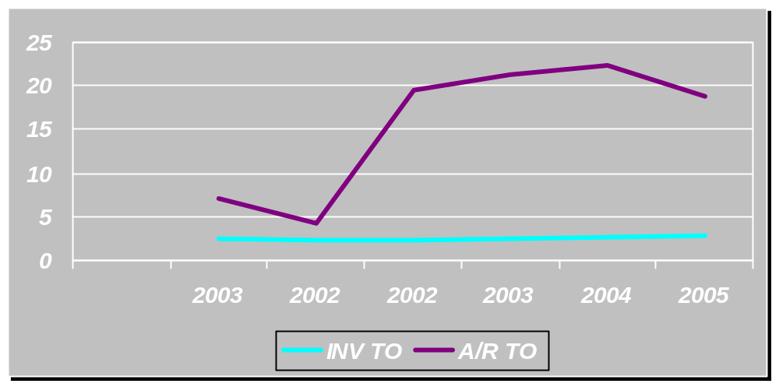

GRAPH SHOWING COLLECTION DAYS AND INV. SELLING DAYS

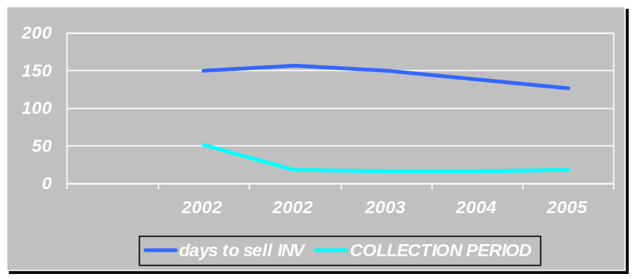

7. Total Assets Turnover:

Total asset T/O = Sales
Avg. total asset

It is used in evaluating a company is ability to use its asset to generate revenue. The total assets turnover shows increase in year 2002, as it was 1.07 as compare to1.16 in 2005. This is mainly because relative increase in sale is more as compare to total asset.

LEVERAGE RATIOS:

Solvency is a company’s ability to meet its long-term obligations as they become due. When debt is excessive, additional financing should be obtained primarily from equity sources.
8. Debt-to-Asset Ratio

Debt-to Asset Ratio = Total Debt
Total Assets

The company’s debt ratio decreased from 0.8539 in year 2004 to 0.837 in year 2005.this show a bit less reliance on debt due to which the company may not face the difficulty in meeting its interest and principal payments on time. On the other hand, the decreased reliance on leverage may decrease favorable leverage
9. Total Capitalization Ratio:

Total Capitalization = Total Debt
Total Capitalization

This ratio shows importance of long term debt to the long-term financing of the firm. In 2002 it was 0.9 where as it increases to 0.94 in 2005.

10. Debt/ Equity Ratio
Debt / Equity Ratio = Total Liabilities
Stockholder equity

The debt to equity ratio has increased over time. It was 1.22 in year 2002 and increased to 1.32 in year 2005. This is a good sign from the point of view of company, because reliance on debt may increase favourable leverage.

11. Interest Coverage Ratio
Times Interest Earned = EBIT
Interest expenses

It shows how much a decline in earning a company can absorb. The time interest earned ratio increased from 2.02 in 2002 and increased to 3.22 in 2005.

PROFITABILITY RATIOS
It shows the financial position of the company is whether the company earns satisfactory profit and return on investment.

12. Gross Profit Margin

Gross Profit Margin = Gross profit / Net sales

The gross profit margin remained stable, which is a true sign. There was slight increase in the gross profit margin in year 2004& 2005.

13. Net Profit Margin
Profit margin = Net Income
Net sale

It produce the cost structure, production efficiency and pricing the company. The net profit margin has slightly decreased from 4.49% in 2002 to 4.05% in 2005, which is a true sign. This indicates that the company’s profitability from sales is nearly stable.

14. Return on Investment:
Return on Investment = Net income
Average Total Assets

The return on total asset shows increasing trend over the period of time. The ROA has increased from 6.29% in year 2002 to 7.08% in year 2004 and decrease in 2005 to 6.88 %. The increase in ROA shows a good trend because it shows increase in the efficiency of assets to generate income except in 2005 which is showing a decline.

15. Return on Equity:
Return on Common Equity = Earning available to common stockholder
Average stockholder equity
ROE shows the same trend as that other profitability ratios. It has decreased over the year. In year 2002 it was 17.45% and in year 2004 it was 14.97% and increases in 2005 to 16.41%. This is not a favorable sign for stockholders because the profitability on the capital supplied by them is not stable.

GRAPH SHOWING NP MARGIN, ROA AND ROE
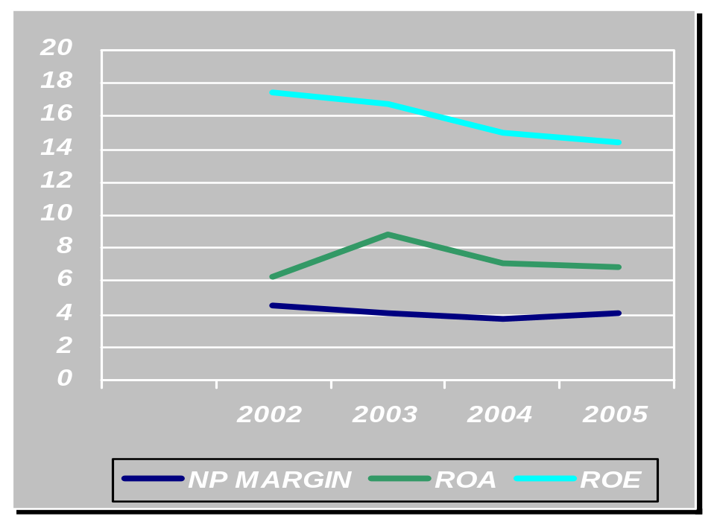

16. Return on Capital Employed:

Return on Capital Employed = EAT
Capital Employed

The ROI ratio in 2004 is 11.77 and it is 14.88 in 2005 that means the company is making more investment and the return on investment is increasing. This also shows the efficiency of the management.

Du Pont Analysis

Earning Power Sales Profitability Assets Efficiency

ROI=EAT Net Profit Margin=EAT Total Asset Turnover=Net Sales
Total Assets Total Sales Total Assets

6.88 % 4.05 % 1.16

MARKET RATIOS

17. Price Earning Ratio:

Price Earning Ratio = Market Price per Share
Earning Per Share

By relating share prices to their actual profits, the P/E ratio highlights the connection between share prices and recent company performance. This ratio has increased to 9.13 in 2005 from 4.85 in 2002. The reason basically is that market price of shares of the company has increased

18. Earning Per Share:

Earning Per Share = EAT
No of Shares Outstanding

It has increased to 3.55 in 2003 from 3.44 in 2002 and 2.31 in 2001. It is a good sign for a investor because this shows a growth in future and will encourage the investors to invest more. The bottom line is that earnings drive stock prices. Strong earnings generally result in the stock price moving up (and vice versa.

19. Dividend Per Share:

Dividend Per Share = Dividend Per Share x 100
Earning Per Share

This year dividend has decreased by .25 paisa. i.e. 2.5 in 2003 from 2.75 in 2002. The decrease in dividend has been compensated by market price. But the stockholder will be happy in anyway if he gets money from dividend or capital gain. This low DPS is come from high EPS which means that company is retaining more money in perspective of future growth and this is the reason why market price has increased this year

20. Cash Coverage Ratio:

Cash Coverage Ratio = EBIT + Depreciation
Interest Charge

The cash coverage ratio is decreasing from 3.70 to 2.56. In 2004 the cash coverage ratio show the good answer but it decreases in 2005 that is not good for the business.

21. Book Value Per Share:

Book Value Per Share = Share Capital
Total no of shares outstanding

The book value of the shares in 2004 is 25.89 and in 2005 it is 27.12. This means it shows that the company is making its name in the open market. It is increasing its goodwill

22. Market Value To Book Value Per Share:

Market Value to Book Value per Share = Market Value
Book Value

This ratio shows the consistent result for the last three years but in 2002 it is quite low but in next three years 2003, 2004 and 2005 it shows the consistent figure i.e. 1.41, 1.56 and 1.50.

GRAPHICAL SHOW OF P/E RATIO AND MARKET PRICE

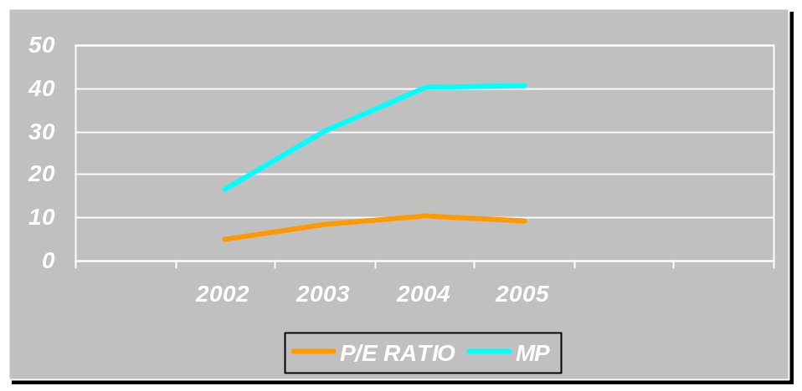

GRAPHICAL SHOW OF DPS AND EPS

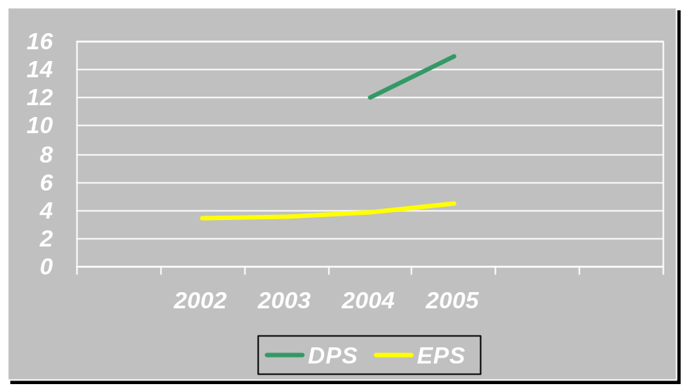

CASH FLOW STATEMENT ANALYSIS

Operating Activities:
The balance of operating activities shows the positive cash flow that shows company increase the balance of cash from operating activities. This show that the sales of the company is good and cost of its product is also decreasing. The company uses its assets efficiently. The management also performs well to increase its sales.
Investing Activities:
The balance of investing activities shows the negative balance this means company is expanding its business by purchasing new assets.
Financing Activities:
The financing shows the negative balance that means company is paying back its loans in time and dividend is also paid to shareholders. This is the health sign for the company.

OVERALL ANALYSIS
The HIGH NOON LABORATORIES LTD. was incorporated in 1984.. The company is enjoying a good position from its start in a country like Pakistan where conditions are volatile and it’s not easy for any company to maintain its stable policies. But the HIGH NOON LABORATORIES LTD. has maintained its policies and profits over the number of years. This might be due to the growth in the industry. But this is one factor. There are some other factors also that result in increase in profit. These factors are extensive marketing and promotion activities and good management practices.
The sales in year 2005 rose to Rs 6.5 billion against Rs 4.5 billion in previous year. The cost of goods sold also increases but the relative increase of cost of goods sold was less than the increase in sales.
The company has strong liquidity position. Over the year the company has strengthen its position. This is a true sign and short-term creditors feel confident while investing in it.
The company has also show high increase in profitability. This was due to the extensive demand of cars. All the profit ratios show improvement in year 2005. And it is good from company’s future prospects.
The efficiency of assets is increasing over the time. It might because of relative extensive increase in sale. This is also a good sign and shows that company is performing.
In the end we can say that HIGH NOON LABORATORIES LTD. has maintained its growth throughout the year. This can be attributed to the good management policies and good market. This increase in future trend might continue because the prevailing market conditions are helping to grow the business.

